

Nama : Azaria Cindy Sahasika

Nim : 2341760169 / 07

Kelas : 1G SIB

Lesson : Dasar Pemrograman

Material : Jobsheet 13

# JOBSHEET 13

**Function 1**

## Learning Outcome

After finishing this lesson, students must be able to:

* 1. Master the basic concept of function, function parameter, return value, and scope of variable.
  2. Implement Java program to create function, as well as for function with parameter, without parameter, with return value, without return value, and to call the function.

## Labs Activity

* 1. **Experiment 1: Function Without Parameter Time: 40 minutes**
     1. Create a new class and save it as **Gratitude_StudentIDNumber.java**.
     2. Create a function named **sayThankyou()** in the class.



* + 1. Create **main()** function and call **sayThankyou()** function from main function..

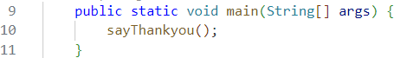

## Question!

1. Does function with no parameter always have void datatype?

* Nope, parameterless functions don't always have to have a void return type. Parameterless functions usually have a return, and a type other than void. This void return type is used when the function doesn't return any value.

1. Is it possible for sentence “**Thank you for…..dst**” to be displayed, without using **sayThankyou()** function? Modify the program so that it displays the sentence without using function!

* Yes, displaying the sentence without using the sayThankyou() function can also directly include the System.out.println statement in the main method, like this:

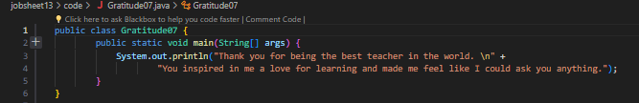

1. What are the benefits of using functions in a program?

* Reusable functions
* Functions are easier to read and understand
* If making changes or updates to the code can be done efficiently

## Experiment 2: Function with Parameters Time: 40 minutes

* + 1. Create a new function named **sayAdditionalGreetings()** that has one parameter with String datatype, in class di dalam *class* **Gratitude_StudentIDNumber.java**!

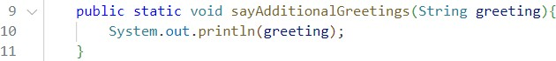

* + 1. Call **sayAdditionalGreetings()** function from ***main***().

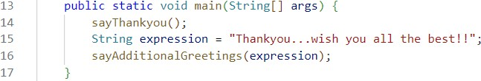

## Question!

1. What is the use of a parameter in a function?

* This parameter serves to receive an input value when called, then this value can be used to perform operations or calculations.

1. Is parameter similar to variable? Please explain!

* This parameter holds the value that will be passed to the function when the function is called.
* While variables are containers for storing data in a program.

1. In the Java programming language, is parameter only used for passing input data? What about output data?

* Not only used to pass input data, parameters in java are also used to return output power. If a parameter accepts an input value then, it can also return to give output data.

## Experiment 3: Function with Return Value Time: 40 minutes

* + 1. Create a new class and save it as **Greetings_StudentIDNumber.java**.
    2. Create a new function to get the recipient of the greeting named **getGreetingRecipient()** that will get the name from the user input and will return the name. That is why this method has String datatype and also has return value.

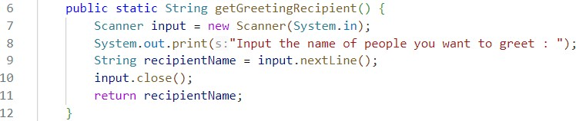

* + 1. Create **main()** function and call **getGreetingRecipient()** function from main!

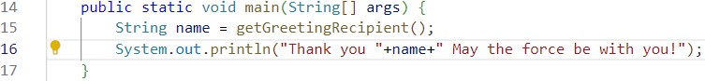

## Question!

1. Explain when do we need to create a function that requires a return value?

* We need to create a function that requires a return value when we want the function to perform some computation or operation and provide the result to the part of the program that called the function.

1. Can a **System.out.println** statement be added inside a function with a return value? What is its impact?

* If the return is in a function, control will be returned to the calling code and the statement after the return will not be executable. So, if System.out.println is put after the return, it will have no impact on the output.

1. Can a function without a return value be called inside the main function without being passed to a variable? Like in experiment 1? Explain!

* A void function (a function without a return value) can be called inside a main function without assigning a return value to a variable. The function will be executed when called, and there is no need to assign a return value to the variable because it does not return a value that can be stored.

## Experiment 4: Calling Function from the Other Function Time: 50 minutes

* + 1. Create a new class and name it as **ExpressingGratitude_StudentIDNumber.java**. In this class, we will attempt to combine the functions that we have previously created in the **Gratitude** and **Greetings** classes.
    2. Create **getGreetingRecipient()** function, that will return the recipient’s name after getting the input from the user.

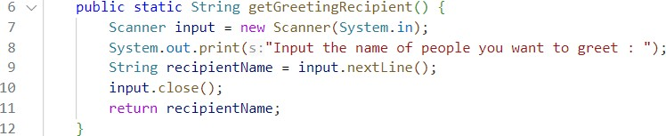

* + 1. 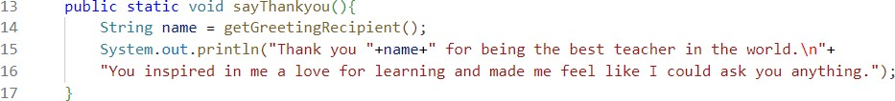Create **sayThankyou()** function, in this function, get the recipient for the greeting by calling **getGreetingRecipient()** function. The recipient will be included in the thank you expression (sentence).
    2. Create **main()** function and call **sayThankyou()** function from there.

## Question!

1. Based on experiment 4, which function will execute first? Please explain!

* **sayThankyou07()** function will be executed first because it is called from the main function. The main function is the entry point of a Java program, and the statements within it are executed sequentially.

1. Which is the correct way to write a function inside a class? Above the main function or below the main function? Please explain!

* The placement of a function within a class, either above or below the main function, does not affect the execution of that function. For code readability and convention, it is common to place the main function at the end of the class.

1. Modify the above program by adding the function **sayAdditionalGreetings**() with a String input parameter. The **sayAdditionalGreetings**() function contains additional remarks or greetings that you want to convey to the greeting recipient.

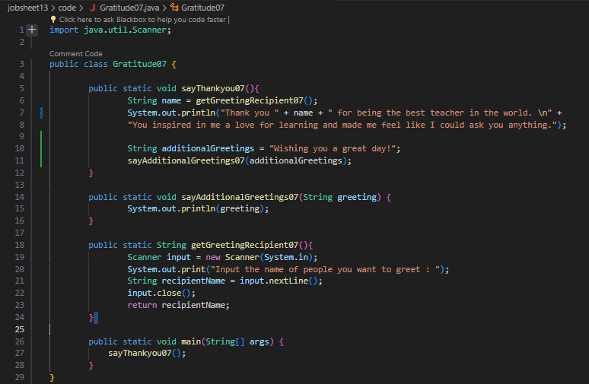

## Experiment 5: Variable Arguments (Varargs) Time: 40 minutes

* + 1. Create a new class and name it as **Experiment5_StudentIDNumber.java**.
    2. Create **show()** function that has **void** datatype, and has 2 parameters with **String** dan

**int** datatype

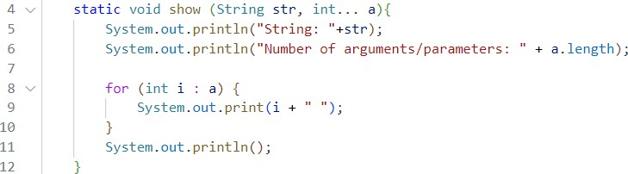

* + 1. Create **main** function and call **show**() function from there.

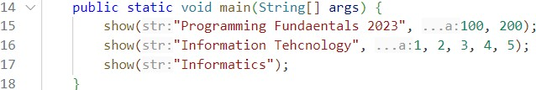

## Question!

1. Explain why the parameter in experiment 5 is written as **int... a**!

* **int... a** to indicate the use of varargs (variable argument lists) in Java. The ellipsis (...) indicates that the method can accept a variable number of arguments of type int, including zero.

1. Mention the example of varargs in implementing code to solve real-world problems! (at least 3)

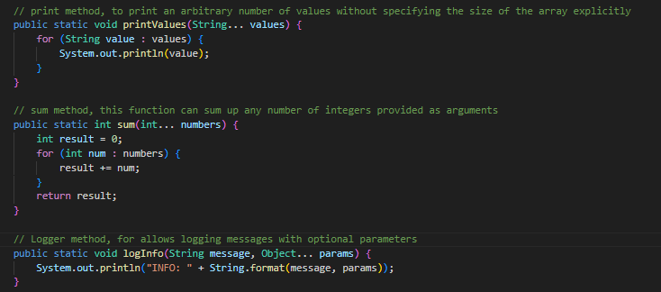

1. Can we use two different data types for varargs in one function? Provide an example!

* It can't, because varargs must have consistent or the same data type.

## Experiment 6: Writing Code, with and without Function Time: 50 minutes

* + 1. Create a new class and name it as **Experiment6_StudentIDNumber.java**.
    2. Create a program to calculate the area of rectangle and volume of cube, without using function!

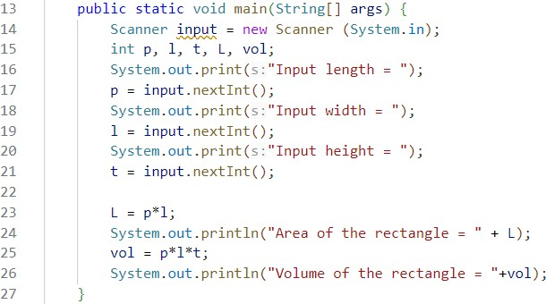

* + 1. The above code, if we implement using function, there will be at least 3 functions:

**calculateArea**, **calculateVolume** and **main** function.

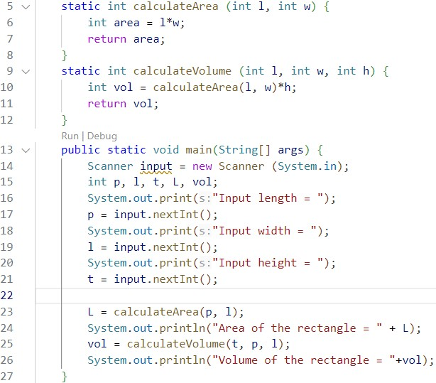

* + 1. Run the program and write down the result you got!

## Question!

1. Explain the execution steps for experiment 6 above!

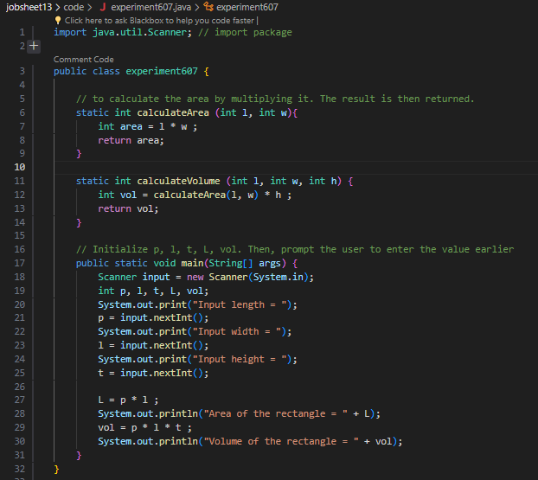

* **calculateArea** and **calculateVolume** is to calculate the area and volume of a rectangular prism based on length (l), width (w), and height (h). However, in the main method, the calculations are done directly without using these functions.

1. What is the output of the program below, then explain the steps of the program!

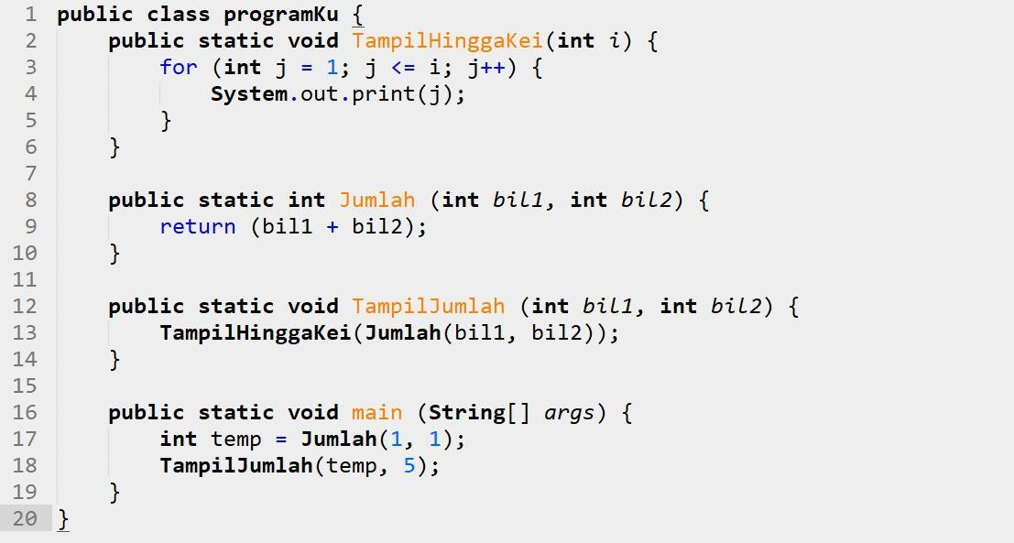

* The output of the above program is the numbers 1 to 10 separated by spaces. what is done in this program is a simple addition operation.

1. When do we need to create a function with and without parameters? When do we need to create a function with and without return value? Explain!

* functions with parameters are used when input values are required to do something, they can be reused or can be called back.
* Use function without parameters when the logic doesn’t depend on external inputs.
* Use function with return value when it’s necessary to use the result of a calculation or task in another part of the program.
* Use function without return value when the task is independent and does not require returns. this is often used to modify global variables.

## Assignment

**Time: 100 minutes**

* 1. Create a new class named **CubeStudentIDNumber** that has function to calculate area and volume!
  2. Create a program to manage the weekly grades (there are 7 weeks) of 5 students. The data must be implemented using 2 dimensional array as follows:

|  |  |  |  |  |  |  |  |
| --- | --- | --- | --- | --- | --- | --- | --- |
|  | **Week 1** | **Week 2** | **Week 3** | **Week 4** | **Week 5** | **Week 6** | **Week 7** |
| **Sari** | 20 | 19 | 25 | 20 | 10 | 0 | 10 |
| **Rina** | 30 | 30 | 40 | 10 | 15 | 20 | 25 |
| **Yani** | 5 | 0 | 20 | 25 | 10 | 5 | 45 |
| **Dwi** | 50 | 0 | 7 | 8 | 0 | 30 | 60 |
| **Lusi** | 15 | 10 | 16 | 15 | 10 | 10 | 5 |

Add functions to retrieve information from the above data with the following details:

* + 1. Function to input students’ grade data.
    2. Function to display all student grades from the first week to the seventh week.
    3. Function to find the week that has the highest grade from all students.
    4. Function to find the student with the highest grade (also display the grade information for each week).
  1. Modify assignment number 2 above by getting the user input to determine the number of students and the number of weeks!

## Group Assignment

Implement the function into your group project. Don't forget, make sure the source code is pushed to your repository.